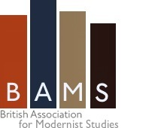 | 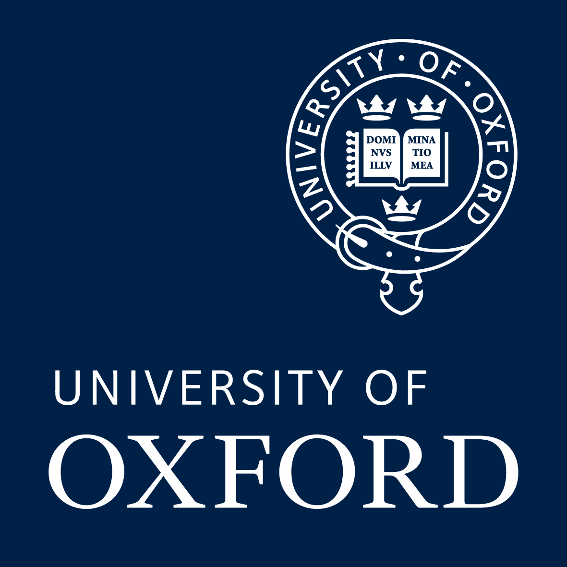

British Association for Modernist Studies
Postgraduate Training Day: Research Skills for Modernist Studies

Hosted by the Faculty of English, University of Oxford
Friday 11 March 2016

The seventh annual BAMS postgraduate training day will explore recent trends in modernist studies and give practical advice on research management, with the aim of preparing you for a career in modernist studies. This event is open to registered on-course doctoral students working in the field of modernism. Registration (including lunch) is free to members of BAMS, and a limited number of travel bursaries are also available to BAMS members whose transport costs over £20. Registration is £5 for non-members. Places are limited, so please register by clicking here (or go to www.oxforduniversitystores.co.uk and search ‘BAMS’) by Monday 7 March. To apply for a travel bursary, please send travel information and/ or receipts to bamsresearchskills@gmail.com. General enquiries may also be directed to this address.

To join BAMS (including a subscription to Modernist Cultures) go to http://bams.ac.uk/membership/. Student rate: £32; online-only £23.

Programme

11:00 Coffee, tea and registration

11:30 Welcome and introduction (Dr Rebecca Beasley, University of Oxford)

11:35 Modernism across the disciplines (Professor David Peters Corbett, University of East Anglia, and María del Pilar Blanco, University of Oxford)
Workshop discussion of modernist studies in the context of interdisciplinary research with David Peters Corbett, Professor of Art History and American Studies at the University of East Anglia, and Dr María del Pilar Blanco, Associate Professor in Spanish American Literature at the University of Oxford.

1:15 Lunch

2:00 The textual culture of modernism (Professor Andrew Thacker, Nottingham Trent University)
Why is the material history of modernism important? How were modernist texts published and read? This talk will consider the material history of modernism, examining periodical production, small presses, editing and editions.

3:00 Coffee, tea

3.30 Modernist archives (Dr Suzanne Hobson, Queen Mary, University of London)

4:30 Modernism and public engagement, followed by roundtable Q&A (Professor Alex Goody, Oxford Brookes University)
What is public engagement and what does it mean for modernism studies? What about knowledge exchange and impact? Should I be doing all of these as a postgraduate researcher and how do I do them? This talk will cover these questions and end with a Q&A forum

5:30 To the pub…

