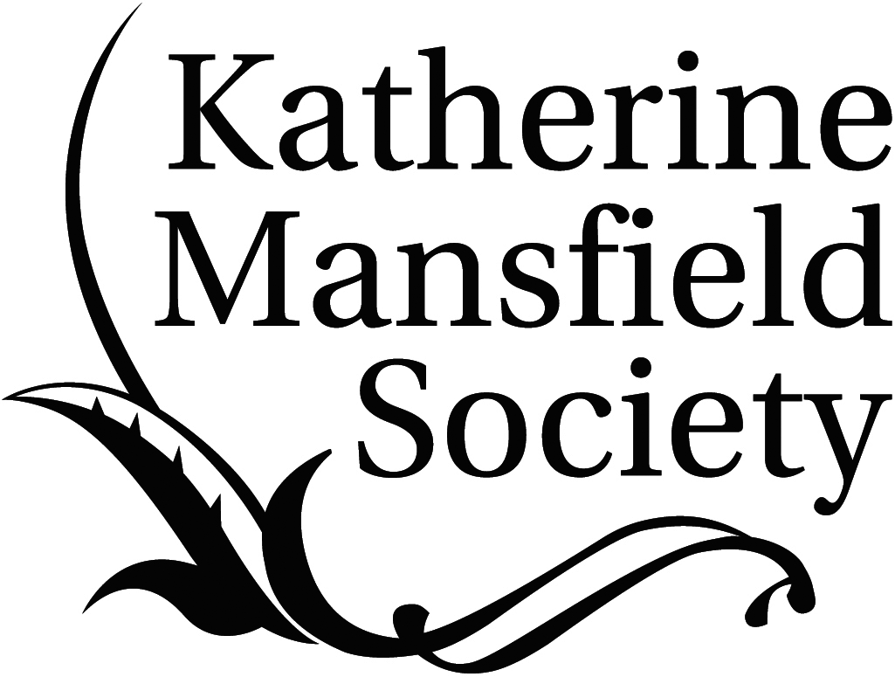

Patron: Dame Jacqueline Wilson

CALL FOR SUBMISSIONS FOR VOLUME 8 OF

Katherine Mansfield Studies

(THE PEER-REVIEWED YEARBOOK OF THE KATHERINE MANSFIELD SOCIETY)

KATHERINE MANSFIELD AND PSYCHOLOGY

Guest Editor: Professor Clare Hanson (University of Southampton, UK)

In a letter of October 1920, Katherine Mansfield distanced herself from the ‘mushroom growth of “cheap psychoanalysis”’ but in the next breath affirmed her belief that ‘with an artist one has to allow – oh tremendously for the subconscious element in his work’. As this suggests, her engagement with the models of subjectivity emerging from contemporary psychology was both complex and ambivalent. This volume invites papers that engage with all aspects of the interplay between Mansfield’s fiction and contemporary psychology and psychoanalysis.

Possible topics include but are not limited to:

the subconscious and the unconscious popular psychology
the psychological novel Gurdjieff
Freud aesthetics and psychology
Jung

Submissions of between 5000–6000 words (inclusive of endnotes), in Word format and using MHRA style, should be emailed to the Guest Editor for this volume, Professor Clare Hanson, accompanied by a 50 word biography: kms@katherinemansfieldsociety.org

A detailed MHRA style guide is available from the Katherine Mansfield Society website:
http://www.katherinemansfieldsociety.org/yearbook-katherine-mansfield-studies/

CREATIVE WRITING

Pieces of creative writing on the general theme of Katherine Mansfield – poetry, short stories, etc., should be submitted to the editors for consideration, accompanied by a 50 word biography: kms@katherinemansfieldsociety.org

DEADLINE FOR SUBMISSIONS: 31 August 2015

