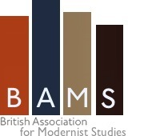
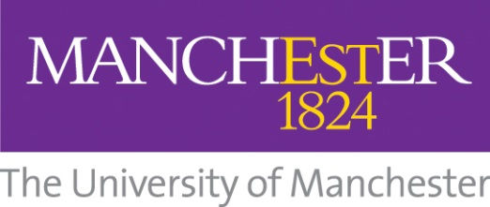
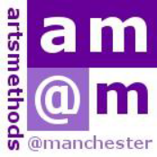

British Association for Modernist Studies
Postgraduate Training Day: Modernist Studies and Teaching
Thurs 29 May 2014

Hosted by the Dept. of English, American Studies and Creative Writing, and with the support of ArtsMethods, University of Manchester
Location: C1.18, Ellen Wilkinson Building (Manchester M13 9PL)

The fifth annual BAMS postgraduate training day will focus on the teaching of modernism. The day will include practical workshops responding to the specific pleasures & challenges of teaching modernism, as well as a broader discussion of pedagogical issues in the field: the institution, theory, practice, & modernism as pedagogy.
Admission is free to members of BAMS (£10 for non-members). Lunch & a reception will be provided. Places are limited; please register before Thursday 22 May by completing the form here.

Programme

10:30 Registration
11:00-11:30 Introduction: Modernism in the universities (Rebecca Beasley, Oxford)
11:30-1:00 Session 1: Teaching modernism: theory (workshop led by Alex Goody, Oxford Brookes)
1:00-1:45 Lunch
1:45-3:15 Session 2: Teaching modernism: practice (workshop led by David James, QMUL)
3:15-3:30 Break
3:30-4:30 Session 3: Research paper (speaker tbc)
4:30-5:00 Session 4: Open discussion and Q&A: Beginning teaching modernism
5:00- Reception
7:00- Optional dinner

